## **Option1: Self rebalancing leaderboard**

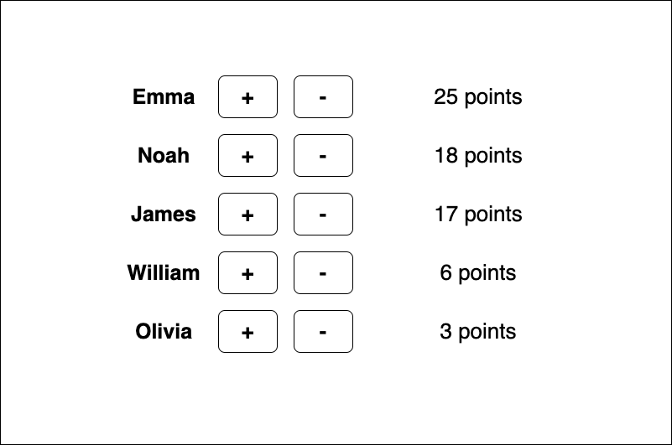

**Requirements:**

* You have 5 users showing in a leaderboard
* All users start with 0 points
* As you click +/-, the leaderboard updates and users are re-ordered based on score
* Names sorted alphabetically if they are tied

**Guideline:**

* Please include a readme file with instructions to run the application
* We are opened to your choice of language both of backend/frontend
* Feel free to incorporate styling libraries where you see fit
* Unit test for areas you see fit
* Please send the zip file of the repository